Cs 406 lab manual

2. Write a program to show Scope of Variables

public class VariableScopeExample

{

private static int x=1;

public static int y=5;

public static void main(String[] args)

{

System.out.println("Qass variable x "+x );

System.out.println("Local variable y "+y);

someMethod();

}

public static void someMethod() {

System.out.println("Qass variable x fromsomeMethod "+x);

System.out.println("Local variable y fromsomeMethod "+y);

}

}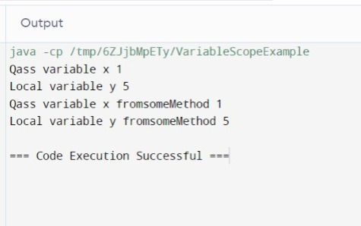

3. Write a program to show Concept of CLASS in JAVA

public class Car

{

private String color;

private String model;

public Car (String colr, String mode)

{

color =colr;

model =mode;

}

public void displayInfo()

{

System.out.println("Car model: "+model);

System.out.println("Car color: "+color);

}

public static void main(String[] arg)

{

Car myCar = new Car("Red", "Toyota Corolla");

myCar.displayInfo();

}

}

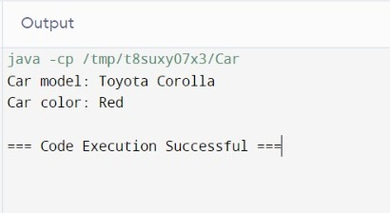

4.Write a program to show Type Casting in JAVA

public class TypeCasting{

public static void main(String[] arg)

{

int myInt=7;

double myDouble=myInt;

System.out.println("Int value="+myInt);

System.out.println("Converted to double="+myDouble);

double anotherDouble= (8.29);

int anotherInt =(int) anotherDouble;

System.out.println("Double value="+anotherDouble);

System.out.println("converted to int="+anotherInt);

}

}

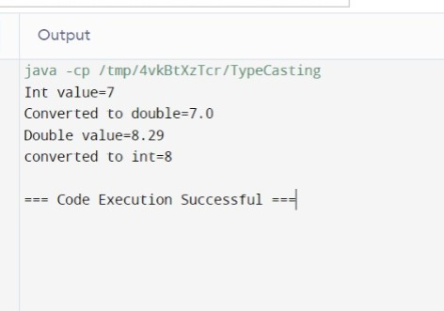

5. Write a program to show How Exception Handling is in JAVA

public class ExceptionHandlingExample {

public static void main(String[] args) {

try {

int[] numbers = {1, 2, 3};

System.out.println(numbers[5]);

} catch (ArrayIndexOutOfBoundsException e) {

System.out.println("An exception occurred: " + e.getMessage());

} finally {

System.out.println("The 'try catch' is finished");

}

}

}

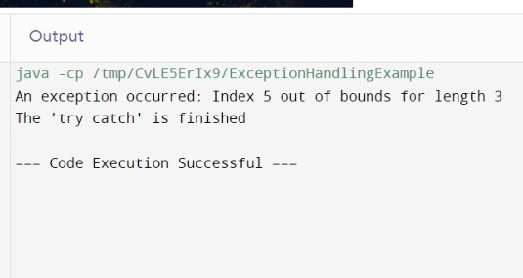

6. Write a Program to show Inheritance

class Vehicle {

// Base class (parent)

protected String brand = "Ford";

public void honk() {

System.out.println("Tuut, tuut!");

}

}

class Car extends Vehicle {

private String modelName = "Mustang";

public void displayModel() {

System.out.println("Brand: " + brand + ", Model: " + modelName);

}

}

public class Main {

public static void main(String[] args) {

Car myCar = new Car();

myCar.honk();

myCar.displayModel();

}

}

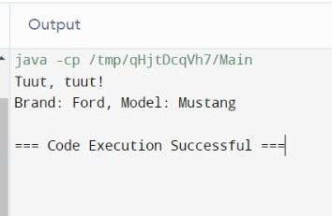

7. Write a program to show Polymorphism

class Animal {

public void sound() {

System.out.println("Some sound");

}

}

class Dog extends Animal {

@Override

public void sound() {

System.out.println("Woof");

}

}

class Cat extends Animal {

@Override

public void sound() {

System.out.println("Meow");

}

}

public class Main {

public static void main(String[] args) {

Animal myAnimal = new Animal();

Animal myDog = new Dog();

Animal myCat = new Cat();

myAnimal.sound();

myDog.sound();

myCat.sound();

}

}

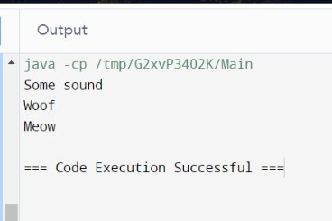

8. Write a program to show Access Specifiers (Public, Private, Protected) in JAVA

class AccessSpecifierDemo {

public int publicVar = 100;

private int privateVar = 200;

protected int protectedVar = 300;

public void display() {

System.out.println("Public: " + publicVar);

System.out.println("Private: " + privateVar);

System.out.println("Protected: " + protectedVar);

}

}

public class Main {

public static void main(String[] args) {

AccessSpecifierDemo demo = new AccessSpecifierDemo();

demo.display();

System.out.println(demo.publicVar);

}

}

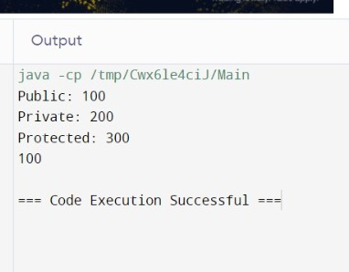

9. Write a program to show use and Advantages of CONSTRUCTOR

class Car {

private String model;

private int year;

// Constructor

public Car(String model, int year) {

this.model = model;

this.year = year;

}

public void displayInfo() {

System.out.println("Model: " + model + ", Year: " + year);

}

}

public class Main {

public static void main(String[] args) {

Car car1 = new Car("Toyota Corolla", 2020);

car1.displayInfo();

}

}

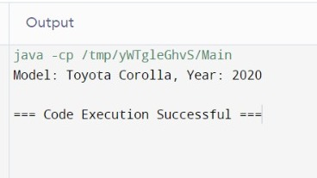

10. Write a program to show Interfacing between two classes

interface Animal {

void sound();

}

class Dog implements Animal {

public void sound() {

System.out.println("Woof");

}

}

class Cat implements Animal {

public void sound() {

System.out.println("Meow");

}

}

public class Main {

public static void main(String[] args) {

Dog myDog = new Dog();

Cat myCat = new Cat();

myDog.sound();

myCat.sound();

}

}

